

**The Centre for Pediatric Pain Research** is an international leader in children’s pain research. The Interdisciplinary research conducted by our faculty, students,

and staff tackles many facets of children’s acute and chronic pain. We are committed to conducting high quality research on how to better understand, assess, and manage children’s pain and translating this research into improved practice.

**The International Forum on Pediatric Pain** began in

1996, organized by the faculty of the Centre for Pediatric Pain Research. They hoped to create a multidisciplinary, stimulating, and educational workshop with researchers from around the world. Since then, each Forum has brought together scientists and clinicians for plenary lectures, interactive workshops, and peer-reviewed poster sessions. Held at White Point Beach Resort, IFPP offers a quaint, relaxed atmosphere which allows for networking between colleagues and sharing of current research in all areas of pediatric pain.

**White Point Beach Resort** was built originally as a hunting and fishing lodge in

1928. On November 12, 2011, just after IFPP 2011, tragedy struck. The beloved main lodge burnt to the ground, reducing 83 years of history to ashes. Immediately, the decision was made to rebuild. On November 8, 2012, they reopened with their new main lodge. The familiarity of the original building has been restored with expanded views of the beach and its timeless vista.





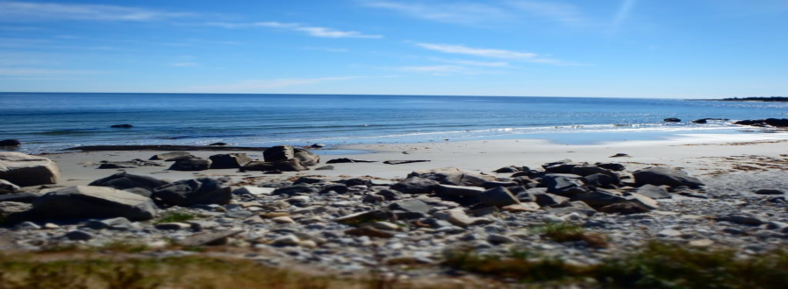

**11th International Forum *on* Pediatric Pain**

**Welcome to Nova Scotia and the 11th International Forum on Pediatric Pain!**

**Engaging for Impact: Partnerships in Pediatric Pain**

**White Point Beach Resort, Nova Scotia, Canada**

**October 12-15, 2017**

CentreforPediatricPainResearch pediatric-pain.ca/ifpp

2017IFPPConference@iwk.nshealth.ca

#IFPP2017









|  |  |
| --- | --- |
| *Thursday, October 12, 2017* | |
| 18:00-22:00 | **Registration**  *Founder’s Room Main Lodge* |
| 19:30 | **Opening Reception**  *Atlantic Room* |
| *Friday, October 13, 2017* | |
| 07:30-08:30 | Breakfast  *Elliot’s Dining Room* |
| 08:30-08:45 | **Welcome**  Centre for Pediatric Pain Research |
| 08:45-10:00 | **Engaging the Media to Improve Pain Care**  André Picard |
| 10:00-10:15 | Break |
| 10:15-11:30 | **Engaging with Friends or Home Alone: Implications for Research & Clinical Practice**  Dr. Paula Forgeron |
| 11:30-12:45 | Lunch  *Elliot’s Dining Room* |
| 12:45-14:00 | **Parents & Professionals Partnering Against Pediatric Pain**  Dr. Mats Eriksson |
| 14:00-14:15 | Break |
| 14:15-15:30 | **Patient Engagement Session** |
| 15:30-16:00 | Poster Set-up  Free Time |
| 16:00-17:00 | **Poster Session #1**  *Lakeside Hall* |
| 17:00 | Barbeque  *Oceanside of Main Lodge* |

*Note: All talks will be held in the Atlantic Room. There will be entertainment on Friday and Saturday evenings in the Founder’s Lounge.*

|  |  |
| --- | --- |
| *Saturday, October 14, 2017* | |
| 07:30-08:30 | Breakfast  *Elliot’s Dining Room* |
| 9:00-10:15 | **Effective Engagement with the Ministry of Health in Pediatric Pain: The Ontario Experience**  Dr. Fiona Campbell |
| 10:15-10:30 | Break |
| 10:30-11:45 | **Bridging Psychology and Neuroscience to Understand and Treat Pediatric Chronic Pain**  Dr. Laura Simons |
| 11:45-13:30 | Lunch  *Elliot’s Dining Room* |
| 13:30-14:45 | **Early Pain Experiences, Attention Deficit Disorders and Pain Perception During the Development**  Dr. Serge Marchand |
| 14:45-17:00 | Poster Set –Up  Free Time  Nordic Swim |
| 16:00-17:00 | **Poster Session #2**  *Lakeside Hall* |
| 17:00 | Gala Dinner  *Atlantic Room* |
| *Sunday, October 15, 2017* | |
| 07:30-09:00 | Breakfast  *Elliot’s Dining Room* |
| 9:00-11:00 | **Debates**  #1 – *The Dirty World of Profit – Should we charge for our innovations?*  Patrick McGrath vs. Cathy Driscoll  #2 – *Bunk, Hope, and Reality – Questioning the use of non-evidence based interventions*  Stefan Friedrichsdorf vs. Bill Zempsky |
| 11:00-11:15 | **Final Remarks**  Centre for Pediatric Pain Research |
| 11:15-12:00 | Lunch and Departure  *Elliot’s Dining Room* |
| 12:15 | Bus Departure to Airport |